Introduction to the Theory of Computing Final Project

Evan Zhuo
Department of Engineering
EECS 510
May 9, 2025

Part 1 – Design a Formal Language
Abstract
This formal language is a basic syntax checker for a single C++ function. The formal language will validate whether the input follows the usual structure of a C++ function. A C++ function usually contains a type name, function name, parentheses, parameters, braces, function definition, and semicolons in a specific order. This formal language will identify a type name, function name, parentheses for parameters, braces for function definitions, and a concluding semicolon after the function definition. This formal language can identify an input with and without a parameter. This formal language will not identify if the type name is a valid type name or check if the parameter is valid or validate the function definition.
Intent
The intent of this formal language is to validate a C++ function definition. It checks if the order of the definition is correct and if it has the necessary syntax for a proper function definition. If the type name, function name, parenthesis, braces, and a concluding semicolon is missing, the input is rendered as an invalid C++ function definition.
Structure
The structure of this formal language will validate if a type name is present. It is followed by a space to delimitate the type name from the function name. After the function name is a left parenthesis to hold a parameter if it exists. A right parenthesis will follow the left parenthesis or the parameter. Between the right parenthesis and the left brace, there can be spaces. After the left brace, a combination of characters and semicolons that mimic a function definition can be placed. However, the function definition must be concluded with a semicolon then a right brace. The right brace concludes the C++ function. If an input matches this formal language order, then the input is valid. Otherwise, it is not valid.

Purpose
The purpose of this formal language is to check a C++ function definition input and validate if it follows the structure. It will accept any input that contains the necessary type name, function name, parentheses, braces, and a concluding function definition semicolon in a specific order. Otherwise, it will reject any input that does not contain one of the previous elements or not in the correct order.
Alphabet
The alphabet for this formal language include:
a | b | c | d | e | f | g | h | i | j | k | l | m | n | o | p | q | r | s | t | u | v | w | x | y | z |
( | ) | { | } | ; | _*
*note: _ represents a space in this formal language.
Semantics
Valid Rule:
type_name function_name(optional_parameter) {function_definition;}

Part 2 - Grammar
Context-Free Grammar (CFG)
This formal language will be represented with context-free grammar. The context-free grammar will look like the following:
S -> CT
T -> CT | UN
N -> CN | (P
P -> CP | )Q
Q -> UQ | {F
F -> CF | UF | ;E
E -> CF | }
C -> a | b | c | d | e | f | g | h | i | j | k | l | m | n | o | p | q | r | s | t | u | v | w | x | y | z
U -> _

Variable Explanation
S is the start state.
T is the type name state.
N is the function name state
P is the parameter state.
Q is the in-between parenthesis and brace state.
F is the function definition state.
E is the post-semicolon state and is the terminating (end) state of this formal language.
C is the character state.
U is the space/underline state.

Part 3 – Automaton
Pushdown Automata to represent the context-free grammar:
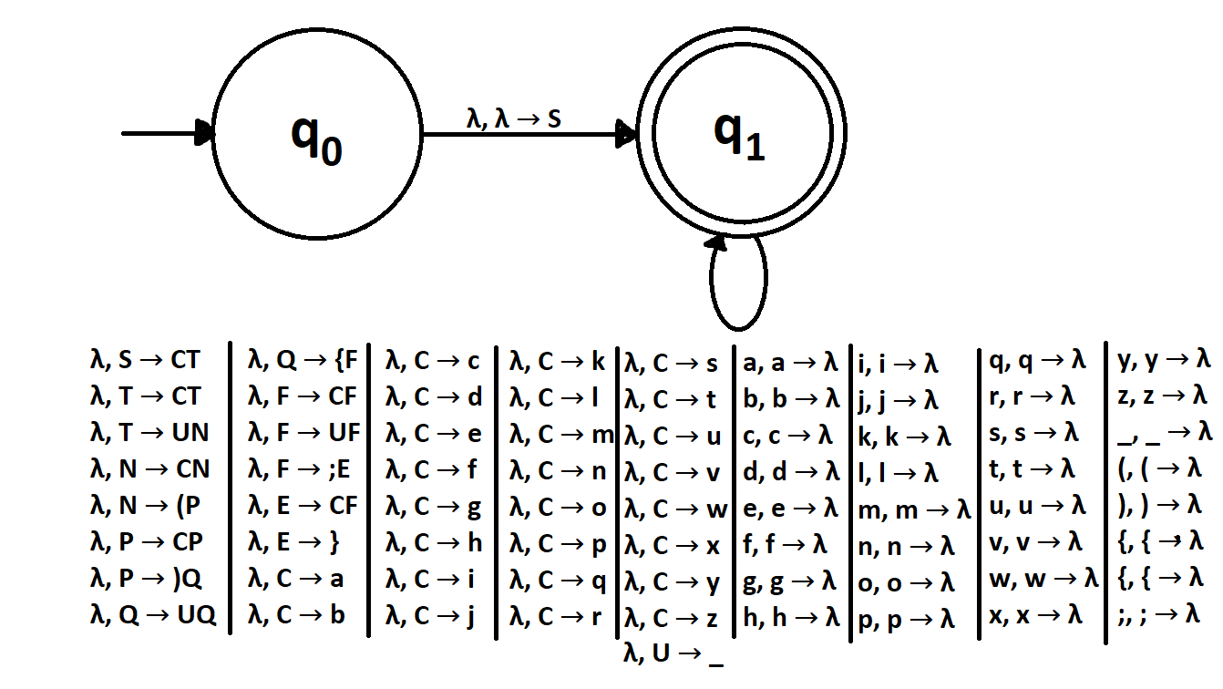Figure 1: Pushdown Automata

Part 4 – Data Structure
Load File Content
Line 1: A whitespace-separated list of the states
Line 2: A whitespace-separated list of input symbols
Line 3: A whitespace-separated list of stack symbols
Line 4: The start state
Line 5: The accept state
Line 6-79: Each line represents one transition with each transition containing five whitespace-separated elements:
1) the state the transition leaves from
2) the symbol popped from the input
3) the state the transition goes to
4) the stack pop element
5) the stack push element(s)

Part 5 – Testing
Valid Input: void func(param) {funcdef;}
Accept
q0 v q1 | Stack: ['/']
q1 v q1 | Stack: ['S']
q1 v q1 | Stack: ['T', 'C']
q1 v q1 | Stack: ['T', 'v']
q1 o q1 | Stack: ['T']
q1 o q1 | Stack: ['T', 'C']
q1 o q1 | Stack: ['T', 'o']
q1 i q1 | Stack: ['T']
q1 i q1 | Stack: ['T', 'C']
q1 i q1 | Stack: ['T', 'i']
q1 d q1 | Stack: ['T']
q1 d q1 | Stack: ['T', 'C']
q1 d q1 | Stack: ['T', 'd']
q1 q1 | Stack: ['T']
q1 q1 | Stack: ['N', 'U']
q1 q1 | Stack: ['N', '_']
q1 f q1 | Stack: ['N']
q1 f q1 | Stack: ['N', 'C']
q1 f q1 | Stack: ['N', 'f']
q1 u q1 | Stack: ['N']
q1 u q1 | Stack: ['N', 'C']
q1 u q1 | Stack: ['N', 'u']
q1 n q1 | Stack: ['N']
q1 n q1 | Stack: ['N', 'C']
q1 n q1 | Stack: ['N', 'n']
q1 c q1 | Stack: ['N']
q1 c q1 | Stack: ['N', 'C']
q1 c q1 | Stack: ['N', 'c']
q1 ( q1 | Stack: ['N']
q1 ( q1 | Stack: ['P', '(']
q1 p q1 | Stack: ['P']
q1 p q1 | Stack: ['P', 'C']
q1 p q1 | Stack: ['P', 'p']
q1 a q1 | Stack: ['P']
q1 a q1 | Stack: ['P', 'C']
q1 a q1 | Stack: ['P', 'a']
q1 r q1 | Stack: ['P']
q1 r q1 | Stack: ['P', 'C']
q1 r q1 | Stack: ['P', 'r']
q1 a q1 | Stack: ['P']
q1 a q1 | Stack: ['P', 'C']
q1 a q1 | Stack: ['P', 'a']
q1 m q1 | Stack: ['P']
q1 m q1 | Stack: ['P', 'C']
q1 m q1 | Stack: ['P', 'm']
q1 ) q1 | Stack: ['P']
q1 ) q1 | Stack: ['Q', ')']
q1 q1 | Stack: ['Q']
q1 q1 | Stack: ['Q', 'U']
q1 q1 | Stack: ['Q', '_']
q1 { q1 | Stack: ['Q']
q1 { q1 | Stack: ['F', '{']
q1 f q1 | Stack: ['F']
q1 f q1 | Stack: ['F', 'C']
q1 f q1 | Stack: ['F', 'f']
q1 u q1 | Stack: ['F']
q1 u q1 | Stack: ['F', 'C']
q1 u q1 | Stack: ['F', 'u']
q1 n q1 | Stack: ['F']
q1 n q1 | Stack: ['F', 'C']
q1 n q1 | Stack: ['F', 'n']
q1 c q1 | Stack: ['F']
q1 c q1 | Stack: ['F', 'C']
q1 c q1 | Stack: ['F', 'c']
q1 d q1 | Stack: ['F']
q1 d q1 | Stack: ['F', 'C']
q1 d q1 | Stack: ['F', 'd']
q1 e q1 | Stack: ['F']
q1 e q1 | Stack: ['F', 'C']
q1 e q1 | Stack: ['F', 'e']
q1 f q1 | Stack: ['F']
q1 f q1 | Stack: ['F', 'C']
q1 f q1 | Stack: ['F', 'f']
q1 ; q1 | Stack: ['F']
q1 ; q1 | Stack: ['E', ';']
q1 } q1 | Stack: ['E']
q1 } q1 | Stack: ['}']
q1 / q1 | Stack: ['/']

Invalid Input: notvalid function()
Reject

